Business Sales Analysis Dashboard 📊
Project Objective
The objective of this project is to analyze business sales data and generate meaningful insights to support strategic decision-making. The dashboard helps identify:
- Revenue trends over time
- Top-selling and high-profit products
- High-value product categories
- Regional sales performance
- Customer purchasing behavior and sales patterns
Project Overview
This project focuses on transforming raw sales data into interactive visual insights using Excel dashboarding techniques. The analysis includes KPI tracking, category-wise sales comparison, profit analysis, and regional performance evaluation.
Key Features
- Interactive Sales Dashboard
- KPI Cards for Revenue, Profit & Orders
- Monthly Revenue Trend Analysis
- Product Performance Visualization
- Category-wise Profitability Analysis
- Regional Sales Comparison
- Business Insights & Recommendations
🛠️ Technologies Used
- Python
- Pandas
- NumPy
- Plotly
- HTML/CSS
- Data Analytics
- Business Intelligence Concepts
- 📂 Project Structure
- Business-Sales-Performance-Analytics/
- │
- ├── dashboard/
- │ ├── business_sales_dashboard.xlsx
- │
- │
- ├── python_code/
- │ └── sales_analysis.py
- │
- ├── report/
- │ └── business_sales_analysis_report.pdf
- │
- ├── dataset/
- │ └── sales_data.csv
- │
- ├── screenshots/
- │ ├── dashboard_overview.png
- │ ├── revenue_analysis.png
- │ ├── product_analysis.png
- │ └── regional_analysis.png
- │
- ├── notebooks/
- │ └── sales_analysis_notebook.ipynb
- │
- └── README.md

📊 Dashboard Preview
Dashboard Visualizations
Revenue Analysis
- Monthly sales trend line chart
- Yearly revenue growth
- Seasonal sales patterns
Product Analysis
- Top 10 selling products
- Best profit-generating products
- Product category comparison
Regional Analysis
- Sales by region
- State-wise performance map
- Region profit comparison
Customer Insights
- Repeat customers
- Highest spending customers
- Customer purchase trends
Dashboard Highlights
- KPI Cards for Revenue, Profit, Orders & Customers
- Monthly Revenue Trend Analysis
- Top Products by Revenue & Profit
- Regional Sales Performance
- Category-wise Revenue Distribution
- Interactive Filters and Insights Panel
Key Insights from Dashboard
- Total Revenue: ₹965.40K
- Total Profit: ₹165.00K
- Electronics category contributes highest revenue
- West region leads overall sales performance
- Laptop is the top-performing product
- February achieved highest monthly revenue
Tools Used
- Microsoft Excel
- Data Visualization
- Pivot Tables & Charts
- Business Analytics
Use Cases
- Portfolio Project
- LinkedIn Showcase
- GitHub Repository
- Internship Submission
- Resume Project Demonstration

📷 Screenshots

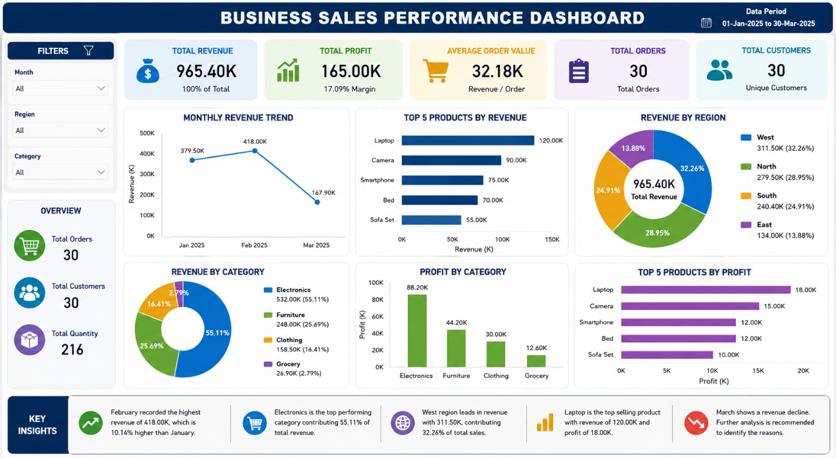

⚡ How to Run the Project
- Clone the repository
git clone https://github.com/your-username/Business-Sales-Analysis.git
- Open the dashboard
online_store_sales_dashboard.html
- Open the business report
business_sales_analysis_report.html

🎯 Learning Outcomes
Through this project, I learned:
- Data Cleaning & Analysis
- Exploratory Data Analysis (EDA)
- KPI Analysis
- Dashboard Development
- Business Reporting
- Data Visualization using Plotly
- Business Recommendation Strategies

